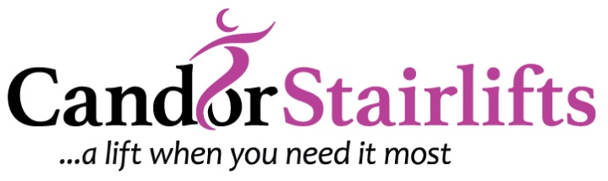

**Candor Stairlifts £100 discount Terms and Conditions**

The £100 discount is only applicable on certain Stairlifts during the promotional period throughout May 2018. The offer will end at midnight on the 31st May 2018.

Once you have submitted your details on the Candor Stairlifts website ([www.candorstairlifts.co.uk/googediscount](http://www.candorstairlifts.co.uk/googediscount)) you will be contacted via phone or email about your £100 voucher. A quotation will be given and the voucher amount deducted. Retrospective discounts will not be available after quotation.

Your £100 voucher must be redeemed via a stairlift order in May 2018. Any order placed after this time till not receive the £100 discount unless this has been agreed with Candor Stairlifts directly as a gesture of good will.

Any existing customers who already have a stairlift installed, will not be able to redeem against an existing purchase, or a purchase that has already been agreed following a quotation from Candor Stairlifts.

Candor Stairlifts reserves the right to change these terms and conditions of this offer at any time without prior notice by amending these online. Once we issue a quote with a validity period, it cannot be altered or changed.

This £100 discount is not valid in conjunction with any other offer or discount.

All new Candor Stairlifts customers qualifying under these terms and conditions for the £100 discount are deemed to have accepted and agree to be bound by the terms and conditions of this offer.

This offer is valid until 31st May 2018.

E&O.E